lH


Open Education Resource:

Flipping the classroom with
MOODLE

Work done as part of AICTE approved FDP on Use of ICT in

Education for Online and Blended Learning

RC1150_007

Rahul G. Sonkamble
Gurunath G. Macchale
Krishna M. Aldar
Prasenjeet D. Patil

Table of Contents

Open Education Resource: Flipping the classroom with MOODLE 1

About the OER 1

Learning Objectives 1

Helpful Documentation for Tool Use 2

Section 2: Design Decisions 3

Nature of Decisions taken 3

Section 3: OER Description 4

Active OER 4

Lesson Settings 4

How to use this OER 8

Best Practices with Lesson Activity 10

Section 4: Evaluating Effectiveness of OER 11

Effectiveness at the student level 11

Effectiveness at consumer level 11

Section 5: Consolidated Log of Team Work 13

Section 6: Building a Community of MOODLE and Flipped Classroom Adopters 14

Possible Sources for Community Building 14

Plans for Community Building 14

Works Cited 15

Open Education Resource: Flipping the classroom with ii

MOODLE

RC1150_007

Rahul G. Sonkamble
Gurunath G. Macchale
Krishna M. Aldar
Prasenjeet D. Patil

Open Education Resource: Flipping the

classroom with MOODLE

About IP addresses

While developing the networks IP addresses concept is very much important. In classfull addressing different classes are very much important. Students should be able to identify the classes.

- OER is downloadable from: https://github.com/RahulSonkamble/iitactivity
https://stargurublog.wordpress.com/

https://stargurublog.wordpress.com/
- Target Audience: Second Year Student (any domain)

- Tags: Flipped Classroom, MOODLE, Educational Technology, Engineering Students

- OER developed in MOODLE 2.3

Learning Objectives

After using this OER, learner will be able to:

- Identify the classes of IP addresses

- Benefits of this session will be student can know the classes of IP

- Basic theory is how communication can be done

- Familiarize themselves with 2 tools for creating concept maps

Open Education Resource: Flipping the classroom | 1
with MOODLE

Helpful Documentation for Tool Use

- for design and development of Lesson Activity in MOODLE (an Open Source Tool)

- for use of PPT

Open Education Resource: Flipping the classroom | 2
with MOODLE

Section 2: Design Decisions

Nature of Decisions taken

The design decisions involved in the creation of this OER were of broadly three types:

- Content Decisions

- Pedagogic Decisions

- Technology Decisions

Content Decisions

The content decisions related to:

- What is IP address? How they can be classified? Why they are useful in networking.

- Presentation in the form of PPT will be provided. They can solve the questions about that topic with moodle also. They can see the video which will be uploaded on the YouTube with the help of screenomatic software.

Pedagogic Decisions

For understanding the concept ppt plus softcopy of book will be provided. As well after reading that they can examine themselves with the help of quiz which will be uploaded on the moodle.
For that you can check the link
https://www.youtube.com/watch?v=1OIKJ0nBu2w&feature=em-upload_owner

Write your Think Phase Question here:  What is the class of the IP address 172.16.16.0 | Duration (in minutes)  3
What will Instructor do: Will provide the information about different classes of IP addresses & will ask students find class of IP address
What will students do: Students will take look at the range of IP address. Then they will find out class.

Write your Pair phase question here: Now discuss with your neighbors and find out what is the correct class. | Duration (in minutes)  6
What will Instructor do: instructor will provide the ranges of class
What will students do: Students will identify the class

Write your share phase task here:  Now share your answer with the class to check whether you have found out correct class. | Duration (in minutes)  6
What will Instructor do: He will conclude the answer by telling the different class range after collecting the best answers from students.
What will students do: Students will discuss with each other and share their answer in the class.

Technology Decisions

While developing the Out-of-Class and In-class activities, the major technology decisions taken were:

- Tool to be used for creating screencast – Jing, as it had a time limit of 5 minutes and provided option for creating videos as .swf files that can be directly played from browser.
https://www.youtube.com/watch?v=1OIKJ0nBu2w&feature=em-upload_owner

- MOODLE Lesson Activity for setting up Out-of-Class segment as it allowed guided self-learning.

Open Education Resource: Flipping the classroom | 3
with MOODLE

Section 3: OER Description(IP addresses)

Active OER

In this OER we will get to know different concepts of the IP addresses.
Class A
Class B
Class C
Class D
Class E

- Prof. Rahul G. Sonkamble
- Prof. Gurunath. G. Machhale
- Prof. Krishna. M Aldar
- Prof. Prasenjeet D. Patil

- Test Course screenshot
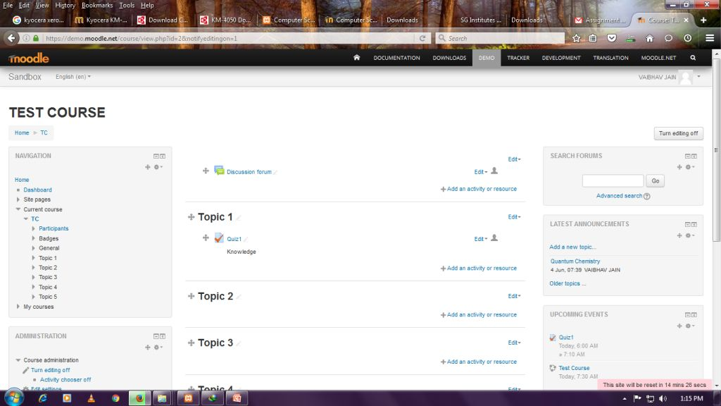

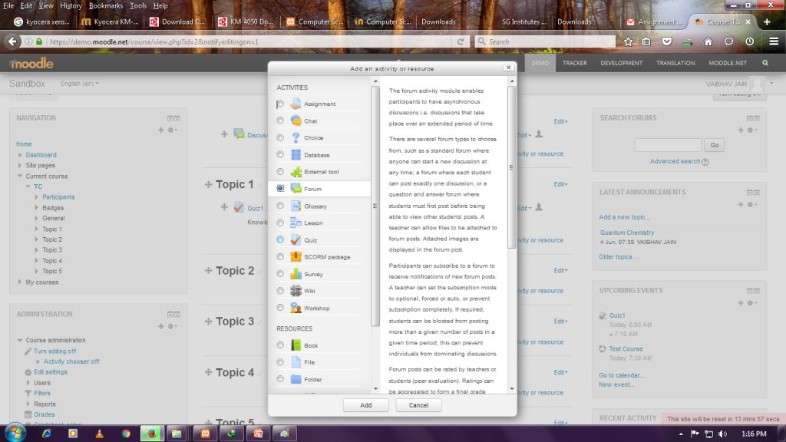
- Add Forum screenshot

- Foum name screenshot
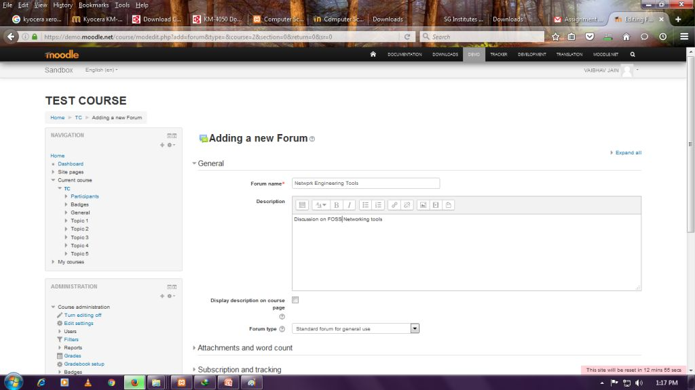

- Forum Display screenshot
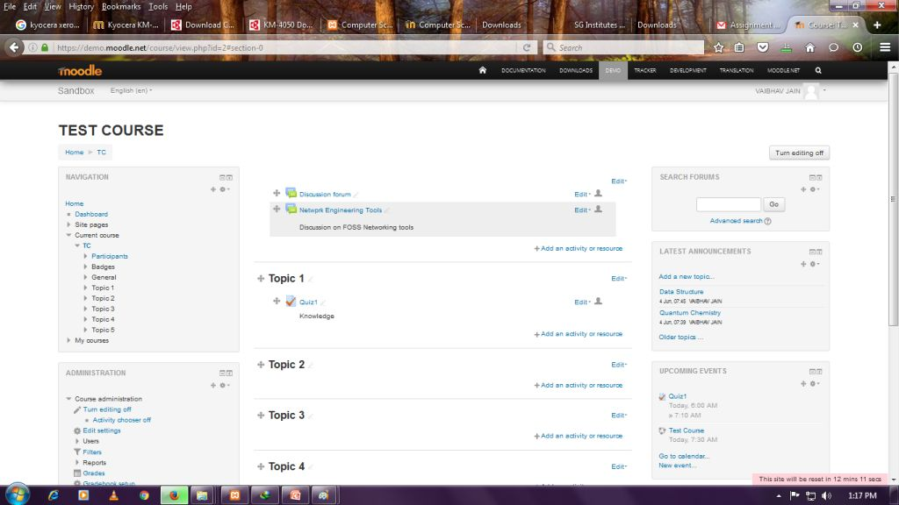

- Category of Question Bank screenshot
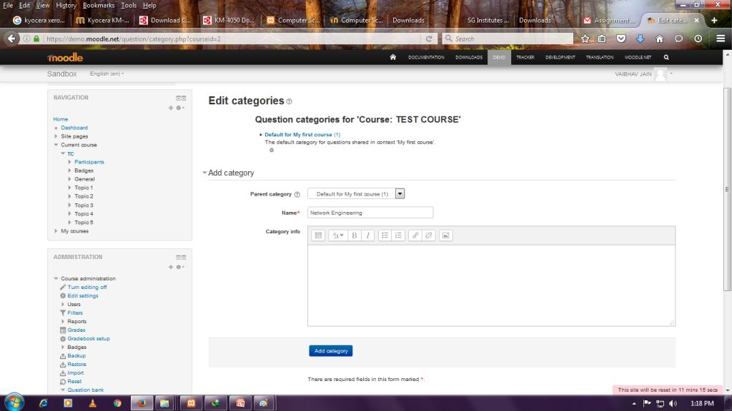

- Import Question in Akien Format screenshot
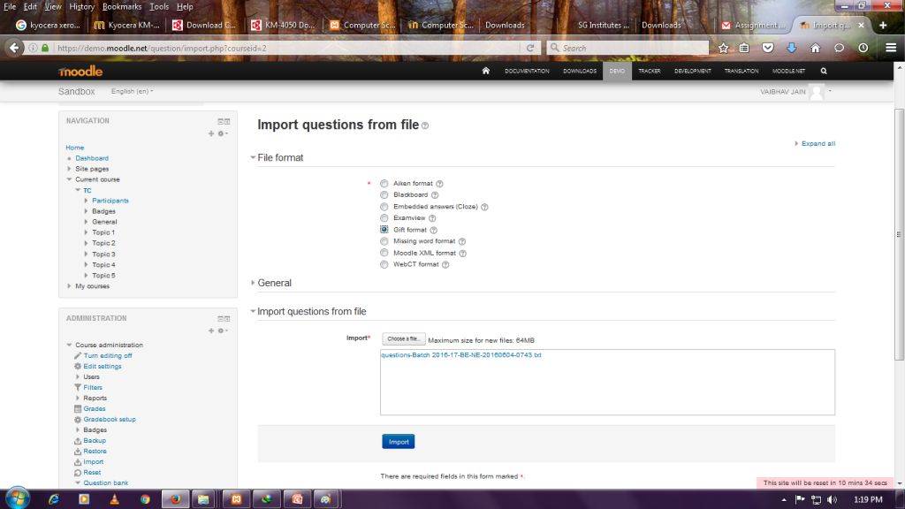

- Import Question from file screenshot
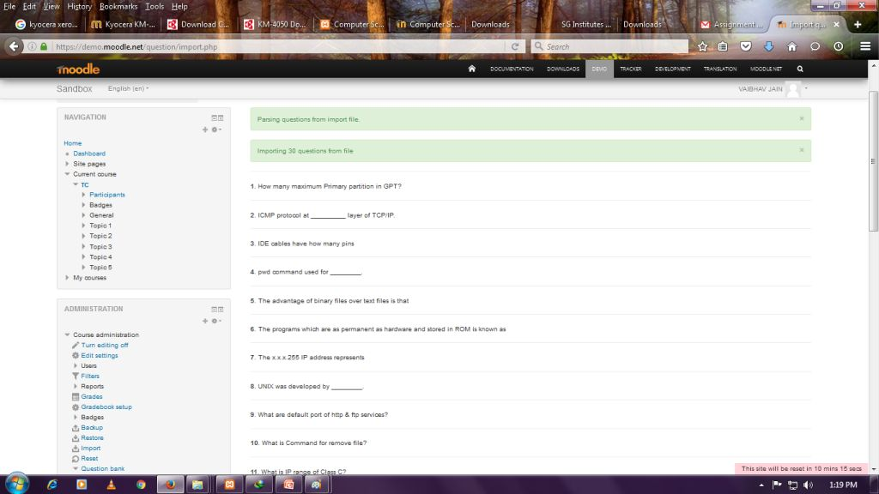
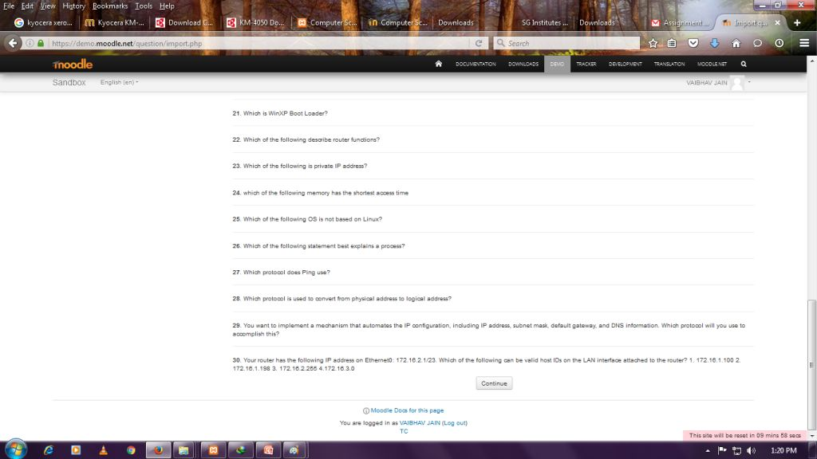

- Question in question bank category screenshot
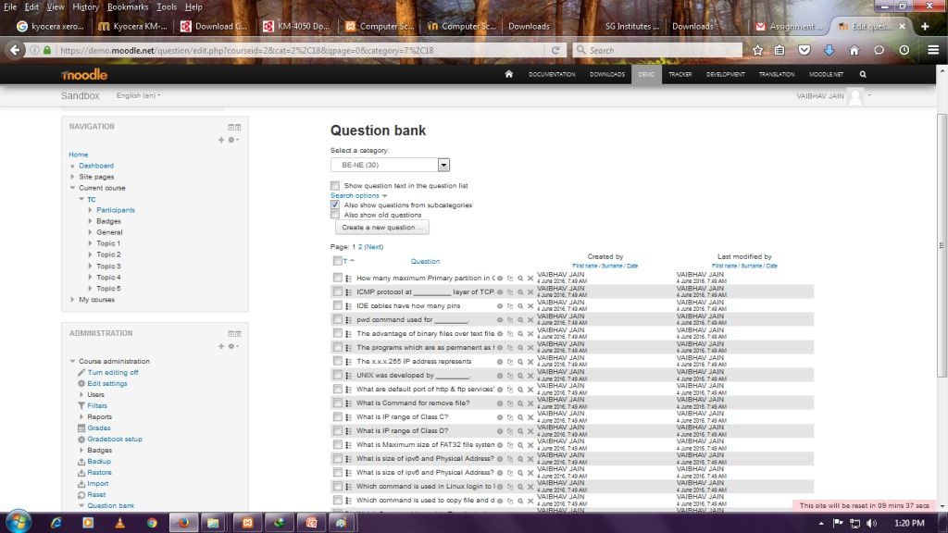

- Add New Quiz screenshot
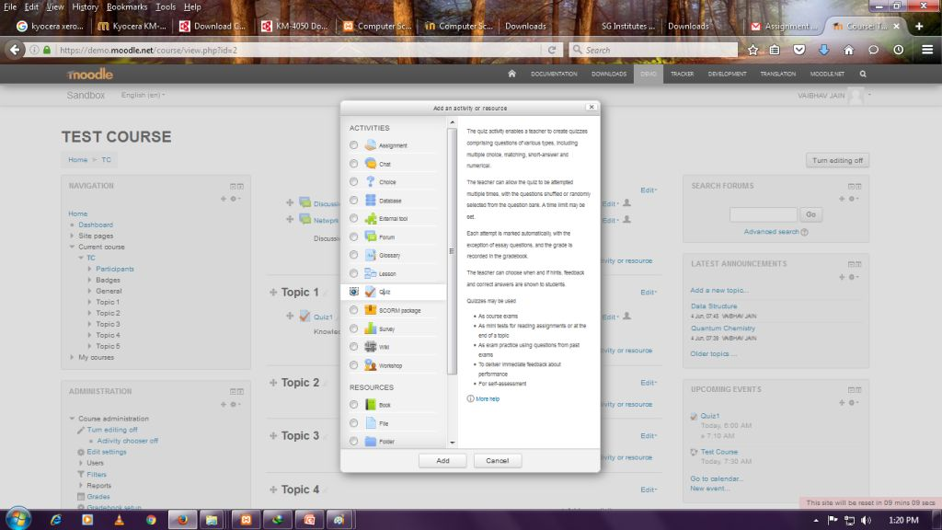

- details for quiz screenshot
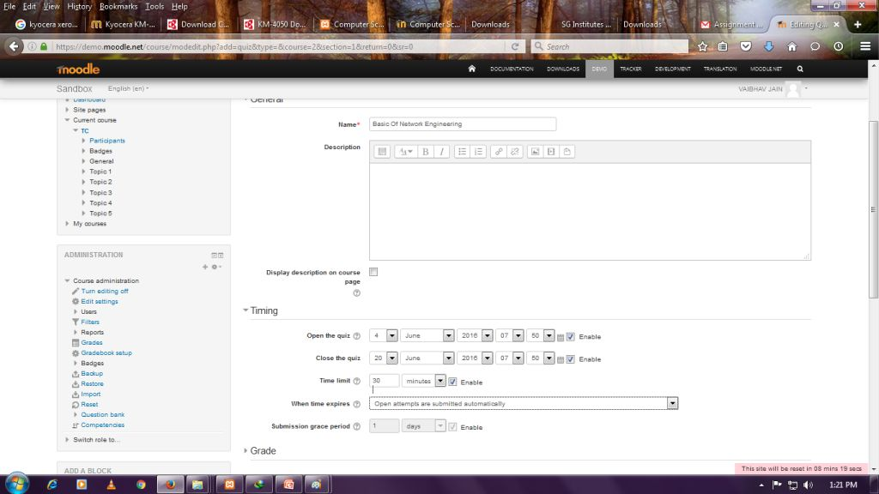

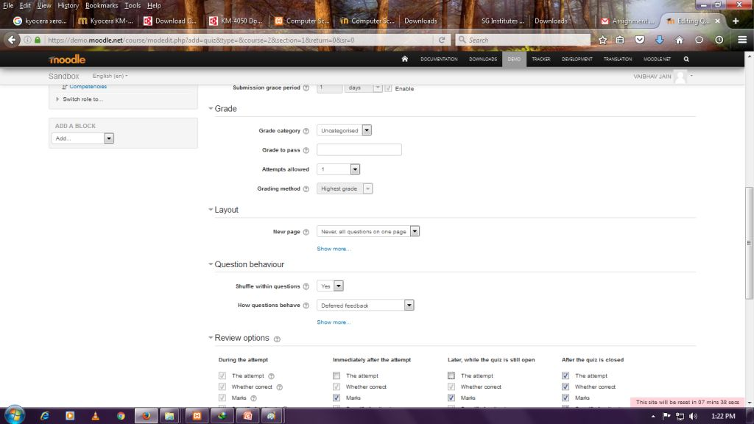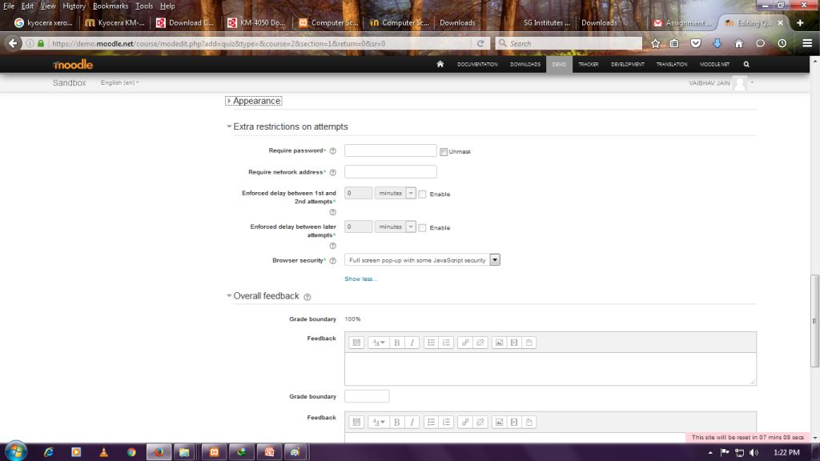
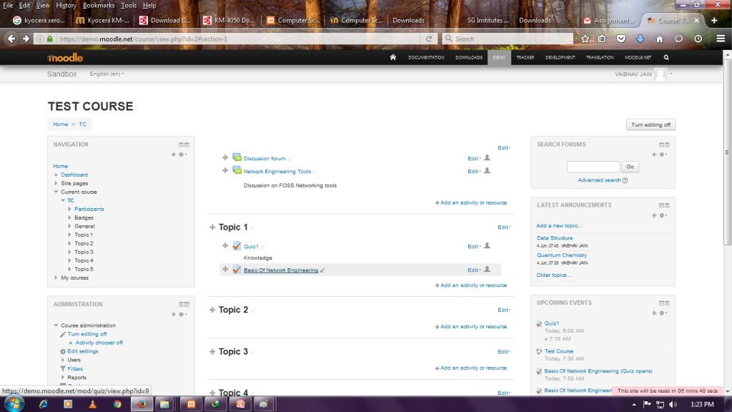

- Edit Quiz screenshot
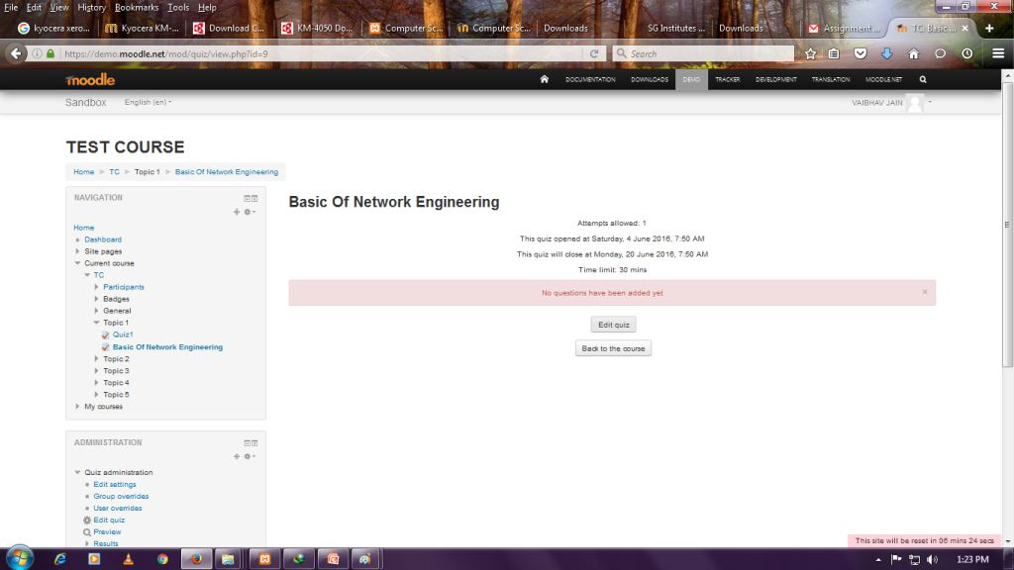

- Add Question to quiz from question bank screenshot
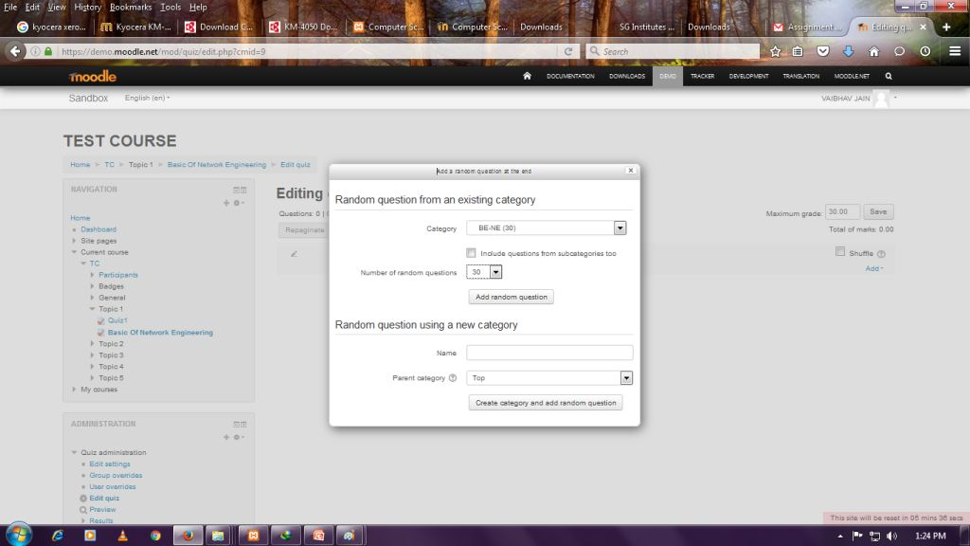

- Add question in quiz screenshot
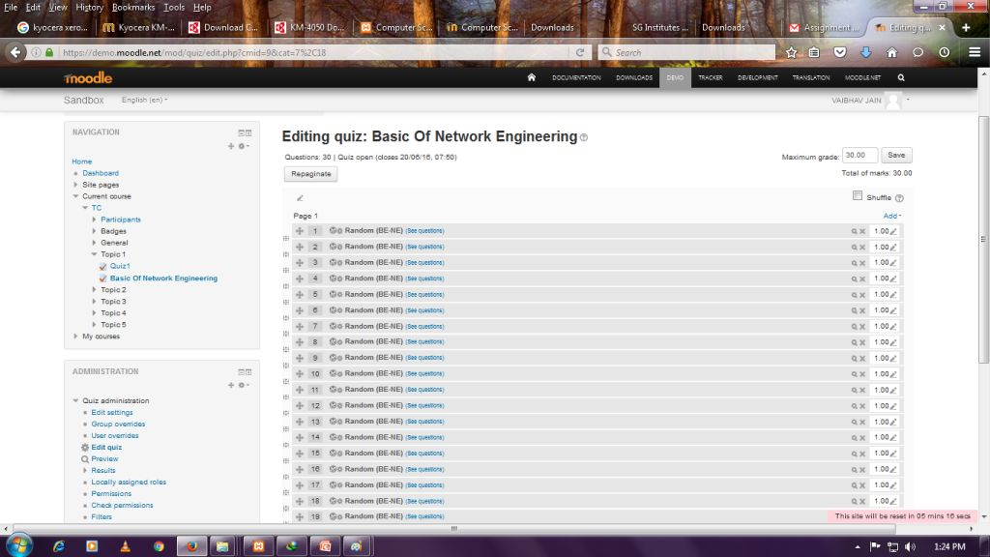

- preview screenshot
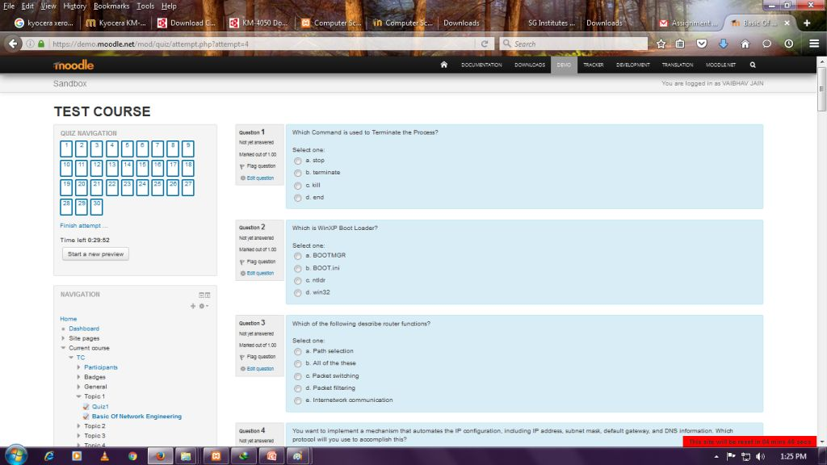

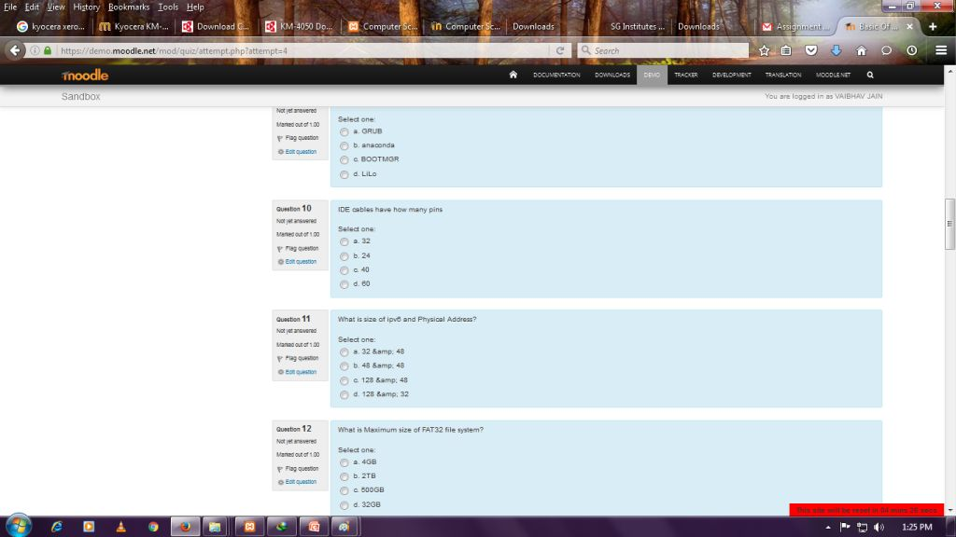

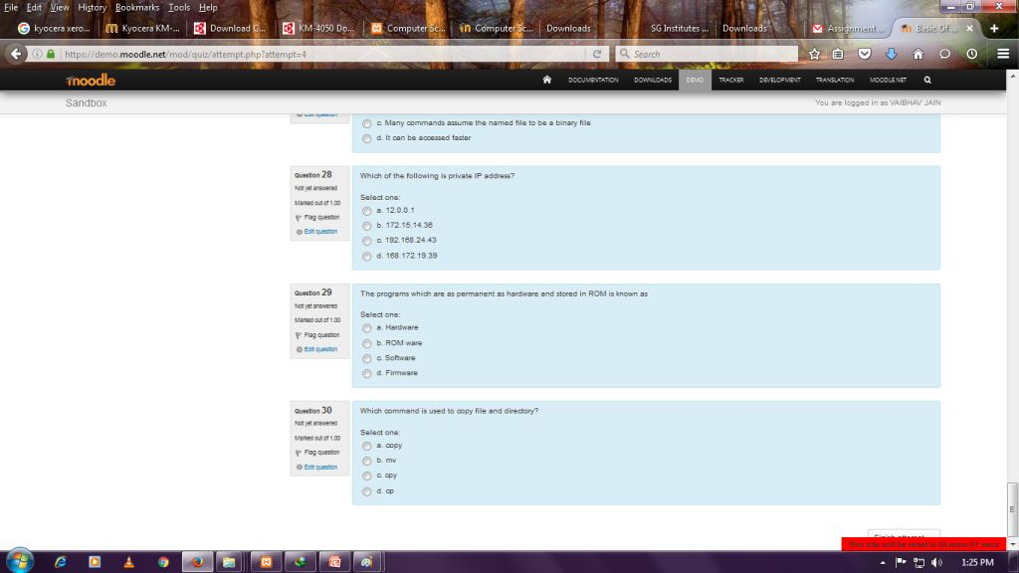

- Finish Quiz screenshot
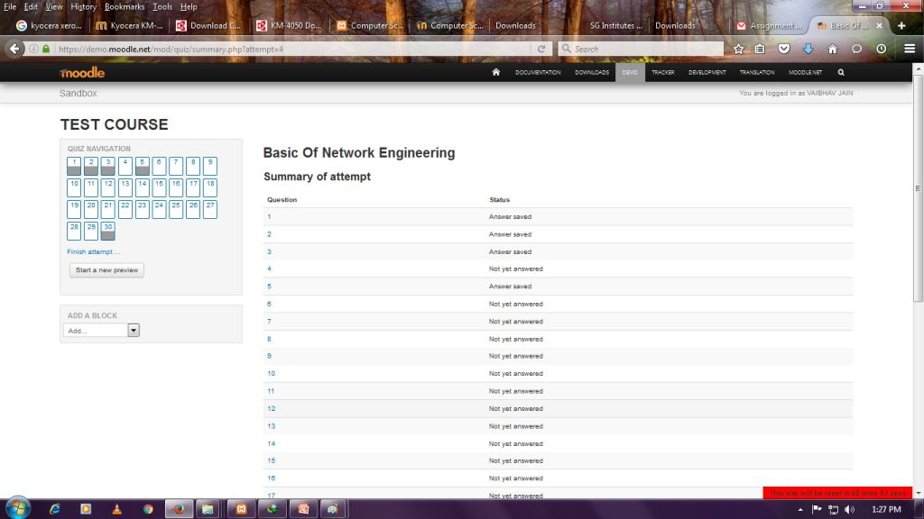

- Attempts screenshot
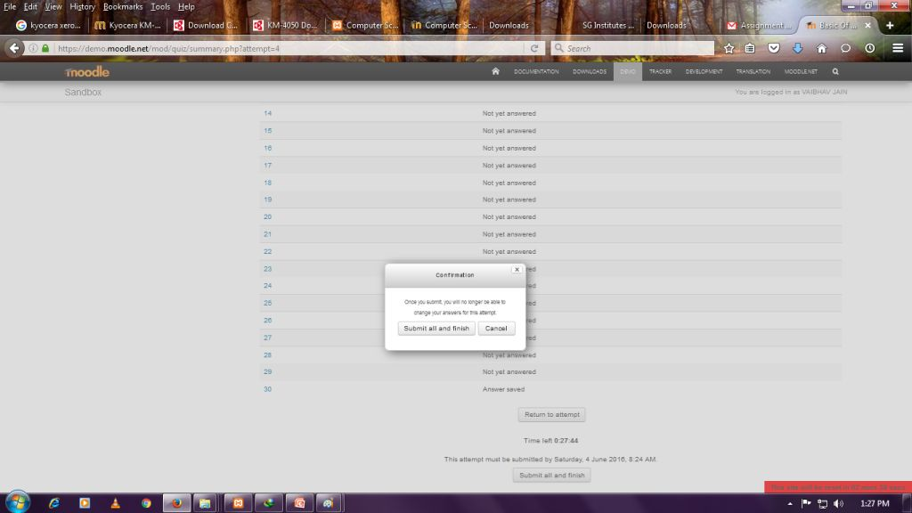

- Quiz Summary screenshot
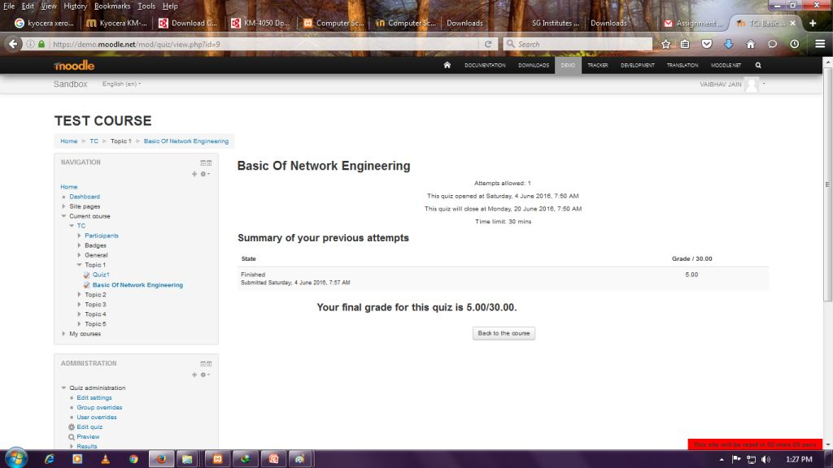

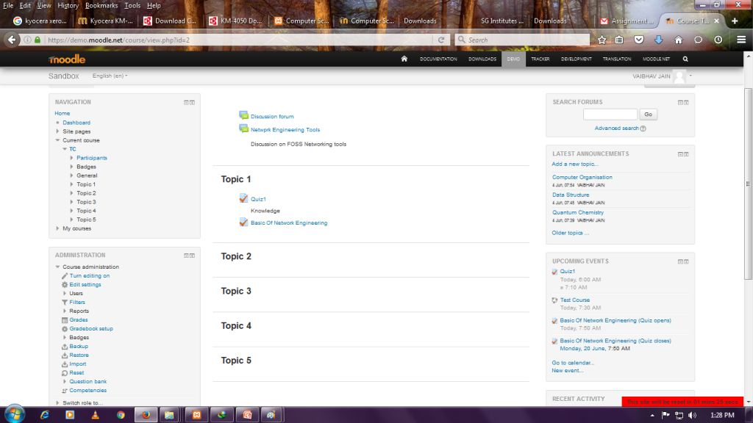

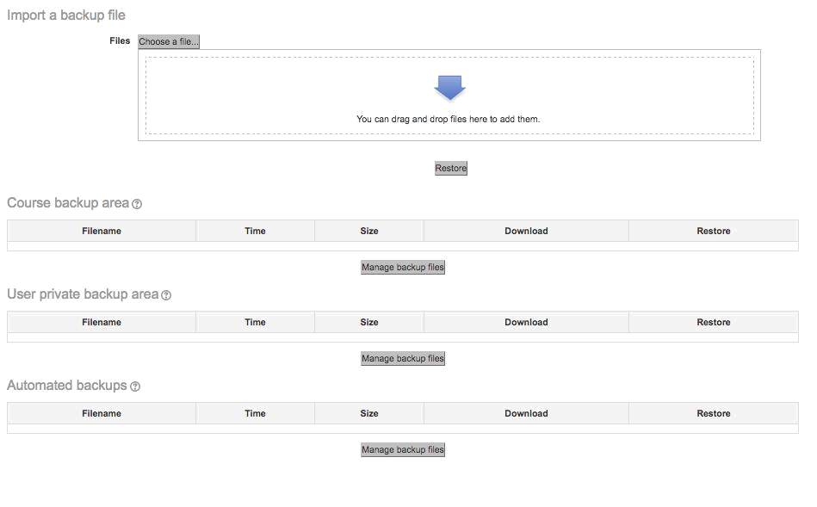

Best Practices with Lesson Activity

Here are some of the best practices from our experience on using this Lesson Activity in classroom:

- Provide this activity at least 1 week in advance.

- Provide minor incentive (marks) for completion of the activity.

- Ensure that there is a tangible output at the end of out-of-class activity to ensure learners are interested (E.g. For the lesson “Concept Map – How?” students had to create concept maps for two videos.)

- It would be good if the screencasts and resources were separately available in a “Resources” folder in the MOODLE course itself. This will take care of common cribs related to “website not available”, “resources not accessible” etc.

Open Education Resource: Flipping the classroom | 10
with MOODLE

Section 4: Evaluating Effectiveness of OER

The OER effectiveness can be assessed at two levels:

- At the student level

- At the consumer level

Effectiveness at the student level

Effectiveness at the student level involves metrics related to student access of the resource and student learning.

The Moodle lesson report can be used to evaluate this effectiveness, with the report showing the total number of students who accessed the reports (along with time) and their marks (based on their answers to MCQs). Additionally there is an option for teacher to grade essays and these marks also will be calculated if needed.

Effectiveness at consumer level

OER consumers are typically teachers who want their students to learn concept mapping. Linking a survey on three main constructs – Ease of Use, Concept Coverage and Concept Complexity, can help in identifying the effectiveness of this OER at consumer level. This has to be done as a follow-up activity.

Implementing Survey

Thus every user who downloads this resource will be asked their email address and as a follow up the survey will be send to their email address.

Survey Questions
Construct | Question | Scale
 | I found it easy to download
 | the Lesson Activity
 | I found the instructions to
 | setup the Lesson Activity
Ease of Use | useful in setting the activity | Strongly Disagree to
 | in my Course | Strongly Disagree to
 | in my Course | Strongly Agree (5-point
 | I was able to successfully | Strongly Agree (5-point
 | I was able to successfully | Likert Scale)
 | create Lesson in my own | Likert Scale)
 | course
 | The Lesson covers the
Concept Coverage | required concepts related to
 | concept maps that I need for
Open Education Resource: Flipping the classroom |  | 11
with MOODLE
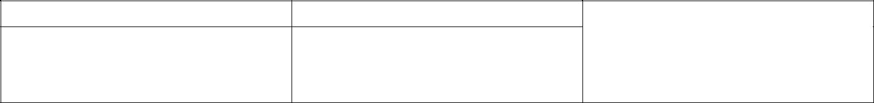
my course

The content inside the Concept Complexity Lesson is too complex for

my students to understand

Open Education Resource: Flipping the classroom | 12
with MOODLE

Section 5: Consolidated Log of Team Work

The consolidated log of team work is as shown below:
Activity | Team Member | Amount of Time | Additional Logs
 |  |  | if any
Discussion | Rahul G. Sonkamble | 15 min
 | Gurunath G. Macchale | 15 min | Plan decision & Work Distribution
 | Krishna M. Aldar | 15 min
 | Prasenjeet Patil | 15 min
Tool Exploration | Rahul G. Sonkamble | 10 min | Video was created
 | Gurunath G. Macchale | 5 min
 | Krishna M. Aldar | 5 min
 | Prasenjeet Patil | 5 min
OER Creation | Rahul G. Sonkamble | 1 day | Repository was created on Github
 | Gurunath G. Macchale | 1 day
 | Krishna M. Aldar | 1 day
 | Prasenjeet Patil | 1 day
OER | Rahul G. Sonkamble | 1 day
Documentation | Gurunath G. Macchale | 1 day | Word document was created.
 | Krishna M. Aldar | 1 day
 | Prasenjeet Patil | 1 day
OER Evaluation | Rahul G. Sonkamble | 1 hr | Edits made in
 | Gurunath G. Macchale | 1 hr | Wiki
 | Krishna M. Aldar | 1hr
 | Prasenjeet Patil | 1 hr

Open Education Resource: Flipping the classroom | 13
with MOODLE

Section 6: Building a Community of MOODLE and Flipped Classroom Adopters

Possible Sources for Community Building

Some of the viable sources for building a community are:

- Teachers who are using MOODLE

- Teachers who plan to use Flipped Classroom Strategies

Plans for Community Building

The resource is already available in the webpage and its access requires the users to provide their email id. Thus there will be a list of interested users whom we can follow up using email. All the interested users can then be connected using a local Wordpress or Moodle website.

Open Education Resource: Flipping the classroom | 14
with MOODLE

Works Cited

- MOODLE. (2015, October) Moodle Docs. [Online]. https://docs.moodle.org/29/en/Lesson_activity

[2] Youtube link. https://www.youtube.com/watch?v=1OIKJ0nBu2w&feature=em-upload_owner

[3] Website information: https://stargurublog.wordpress.com/

Open Education Resource: Flipping the classroom | 15
with MOODLE

